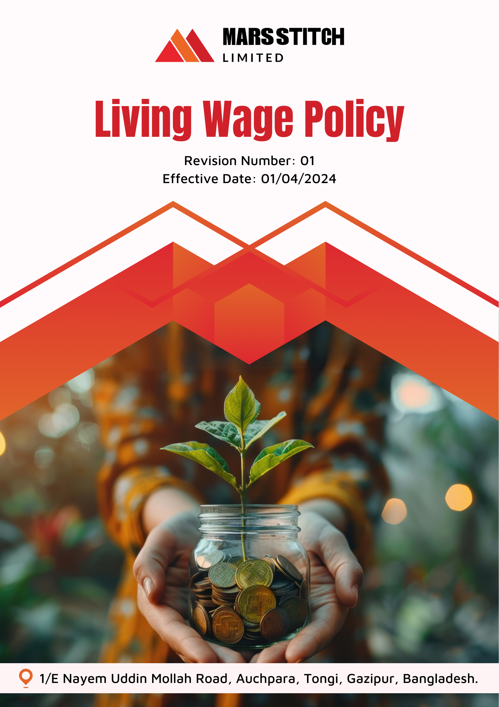

Policy Number

04313

Prepared by

Maria G. White

mariawhite@workerwrite.com
INDEX
⧫ INTRODUCTION 3
⧫ SCOPE 3
⧫ POLICY STATEMENT 3
⧫ KEY FOCUS AREA 4
⧫ QUALITATIVE TARGETS 4
⧫ QUANTITATIVE TARGET 5
⧫ THE ORGANIZATION OR PERSON RESPONSIBLE FOR IMPLEMENTING THE POLICY 5
⧫ CONTINUES IMPROVEMENT 6
⧫ REPORTING 7
⧫ REVIEW MECHANISM 7
⧫ EMPLOYEE ACKNOWLEDGEMENT FORM 8

- INTRODUCTION
Mars Stitch Ltd. is dedicated to fostering a fair and equitable workplace by ensuring that all employees earn a living wage. A living wage represents the income necessary to meet basic needs such as food, housing, healthcare, education, and other essentials, while also allowing for some discretionary income. This commitment reflects our core values of dignity, respect, and fairness.

At Mars Stitch Ltd., we recognize the transformative impact of living wages on the lives of workers and their families. By embedding living wage principles into our operations, we aim to promote social equity, improve well-being, and contribute to sustainable economic growth.
- SCOPE
This policy applies exclusively to all employees, workers, contractors, contractual worker, subcontractors, internal and external stakeholders of Mars Stitch Ltd. across all operational sites.

Sr. No. | Name of Site | Address
1 | Mars Stitch Ltd. | 1/E Nayem Uddin Mollah Road, Auchpara, Tongi, Gazipur, Bangladesh.
- POLICY STATEMENT
Mars Stitch Ltd. is committed to ensuring that all employees receive a living wage that supports a decent standard of living. By going beyond minimum wage compliance, we aim to establish a benchmark for fair compensation in the textile and garment industry. Through transparency, regular monitoring, and continuous improvement, we will uphold this commitment across all levels of the organization.
- KEY FOCUS AREA
Mars Stitch Ltd. focuses on the following principles to achieve living wage commitments:
- Wage Fairness: Ensure that wages paid to employees meet or exceed living wage benchmarks established by organization.
- Transparency and Monitoring: Maintain clear documentation and conduct regular audits to assess wage compliance across all operations.
- Worker Empowerment: Foster open dialogue with employees to understand their needs and concerns related to wage fairness.
- Continuous Improvement: Regularly review and update wage benchmarks to reflect changes in the cost of living and evolving global standards.
- Public Commitment: Announce living wage targets publicly, reinforcing transparency and demonstrating leadership in ethical wage practices.
- Sustained Living Wage Commitment: Maintain a long-term commitment to continuously paying living wages, ensuring that wage standards evolve alongside economic and social changes.
- QUALITATIVE TARGETS
Mars Stitch Ltd. aims to achieve the following qualitative goals:
Wage Fairness:
- Establish and implement living wage benchmarks across all operational sites.
- Ensure all employees receive fair wages that enable them to meet basic needs.
- Provide additional benefits such as healthcare, education support, and housing assistance to enhance employees' quality of life.
Transparency and Monitoring:
- Conduct annual wage Calculation to ensure compliance with living wage standards.
- Publish annual reports detailing wage practices and progress toward achieving living wage goals.
- Establish grievance mechanisms to address employee concerns related to wage payments.
Worker Empowerment:
- Engage with employees through surveys and forums to gather insights on wage adequacy.
- Provide channels for employees to report wage-related grievances anonymously and securely.
- Offer financial literacy programs to help employees manage their income effectively.
- QUANTITATIVE TARGET
Mars Stitch Ltd. has set measurable targets to reinforce our commitment to living wages, with 2023 as the baseline year.
Wage Fairness:
- Ensure 100% of employees receive wages meeting living wage benchmarks by 2026.
- Provide additional non-monetary benefits, covering 80% of employees by 2026.
Transparency and Monitoring:
- Publish annual wage compliance reports starting in 2024.
- Conduct annualy reviews of wage compliance metrics, aiming to achieve a 20% improvement in compliance scores year-on-year by 2026.
- Resolve 90% of wage-related grievances within 30 days of reporting by 2026.
Worker Empowerment:
- Conduct annual financial literacy workshops for 100% of employees by 2026.
- Establish anonymous grievance mechanisms accessible to all employees by 2026.
- THE ORGANIZATION OR PERSON RESPONSIBLE FOR IMPLEMENTING THE POLICY
Mars Stitch Ltd. has designated a dedicated committee to ensure the successful implementation of the Living Wage Policy. This committee is responsible for monitoring, reviewing, and enforcing the policy while maintaining compliance with internal and external standards:

Sr. No. | Name | Designation | Committee Designation
1. | S.M Azmal Huda | General Manager(Operation) | President
2. | Mahmodul Hasan | Manager – HR, Admin & Com. | Vice President
3. | Eva Akter | Executive-Welfare | Member Secretary
4. | Nonda Gopal | Sr. Executive -Compliance | Member
5. | Md.Shanta | Maintenance In-charge | Member
6. | Md. Masud | Asst. Manager-Admin | Member
7. | Mr. Antar | Asst. Manager-Store | Member
8. | Md. Samim | Cutting Asst. | Member
9. | Md. Nayeem Hosan | Quality Inspector | Member
10. | Mst. Ruma Akter | Operator(Sewing) | Member
11. | Mst. Jushna Begam | Operator(Sewing) | Member
12. | Mst. Mira | Finishing Asst. | Member
- CONTINUES IMPROVEMENT
Mars Stitch Ltd. is committed to continuous improvement in living wage practices through:
- Regular updates to the Living Wage Policy to reflect evolving standards and cost-of-living adjustments.
- Monitoring and evaluating wage practices through independent audits and stakeholder engagement.
- Encouraging feedback from employees to identify areas for enhancement.
- Participating in industry initiatives to advance living wage practices globally.
- REPORTING
To ensure transparency and accountability:
- Annual Wage Report: Publish a comprehensive report detailing wage compliance, progress, and areas for improvement.
- Employee Engagement: Conduct annual meetings to discuss wage standards and collective progress.
- Incident Reporting: Maintain a transparent and accessible system for reporting wage-related concerns.
- REVIEW MECHANISM
This policy will be reviewed annually by the Manager - HR, Admin & Compliance, ensuring alignment with Mars Stitch Ltd.'s living wage commitments and global standards. The Wage Compliance Office will assess the policy's effectiveness, incorporating employee feedback and addressing emerging challenges.

Prepared By : Manager – HR, Admin & Compliance. Approved By : General Manager
Next Review Date : 01/04/2025
- EMPLOYEE ACKNOWLEDGEMENT FORM
By signing this form, employees acknowledge their understanding of and commitment to Mars Stitch Ltd.'s Living Wage Policy. Compliance with this policy is a shared responsibility and an integral part of fostering fair and equitable workplace practices. Employees agree to uphold the principles outlined in this policy and actively participate in implementing fair wage standards.

This includes adhering to the company's standards for wage fairness, transparency, and continuous improvement, as well as promptly addressing and reporting any deviations. By committing to these guidelines, employees play a vital role in supporting Mars Stitch Ltd.'s vision of equity and sustainability.

Employee Name:

Designation:

Signature:

Date:

